How to Send HTML Files
- Download the HTML file(s) above. Open your Downloads folder and double-click to open the file in your browser.
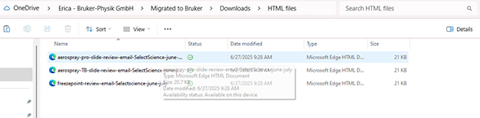
- Drag to select all the content in the file and right-click to Copy.
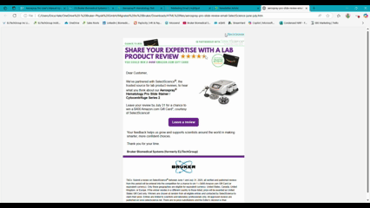
- Create a new email in Outlook and add your desired subject line. Right-click in the body of the email and select Paste.
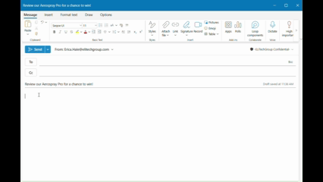
- Add your customers’ email addresses and send.

